COSC 3380

Name: ______________ Seat# ___
Project 3:
(100 points.)
(Due date found in the COSC 3380 Detailed Syllabus!)

Use the COSC3380 Database created in Project 2.

Part 1. Stored Procedures

In contrast to triggers, which are automatically run when a specified event occurs, routines must be explicitly called, just as the MIN built- in function is called. SQL- invoked routines can be either procedures or functions. The terms procedure and function are used in the same manner as they are in other programming languages. A function returns one value and has only input parameters. A procedure may have input parameters, output parameters, and parameters that are both input and output parameters. You may declare and name a unit of procedural code using proprietary code of the RDBMS product being used or invoke (via a CALL to an external procedure) a host-language library routine. SQL products had developed their own versions of routines prior to the issuance of SQL: 1999, so be sure to become familiar with the syntax and capabilities of any product you use. Some of these proprietary languages, such as Microsoft SQL Server’s Transact-SQL and Oracle’s PL/ SQL, are in wide use and will continue to be available. To give you an idea of how much stored procedure syntax has varied across products, Table below examines the CREATE PROCEDURE syntax used by three RDBMS vendors; this is the syntax for a procedure stored with the database.
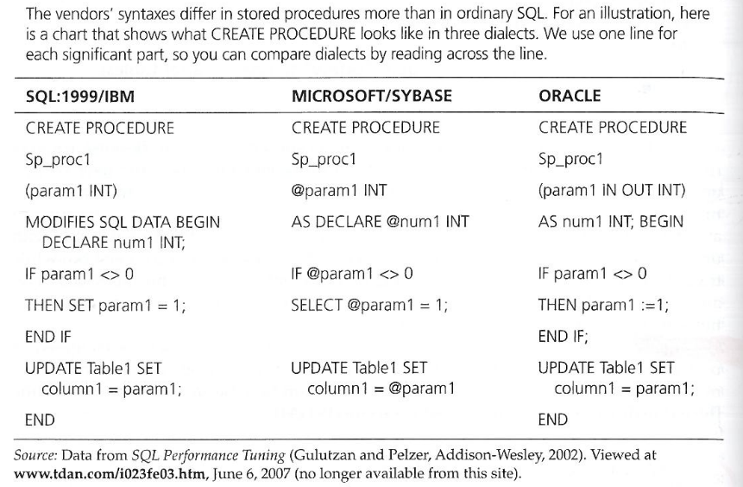

The following are some of the advantages of SQL- invoked routines:

• Flexibility Routines may be used in more situations than constraints or triggers, which are limited to data- modification circumstances. Just as triggers have more code options than constraints, routines have more code options than triggers.

• Efficiency Routines can be carefully crafted and optimized to run more quickly than slower, generic SQL statements.

The SQL: 200n syntax for procedure and function creation is shown in Figure below. As you can see, the syntax is complicated, and we will not go into the details about each clause here. However, a simple procedure follows, to give you an idea of how the code works. A procedure is a collection of procedural and SQL statements that are assigned a unique name within the schema and stored in the database. When it is needed to run the procedure, it is called by name. When it is called, all of the statements in the procedure will be executed. This characteristic of procedures helps to reduce network traffic, because all of the statements are transmitted at one time, rather than sent individually. A procedure can access database contents and may have local variables. When the procedure accesses database contents, the procedure will generate an error message if the user/ program calling the procedure does not have the necessary rights to access the part of the database used by the procedure.

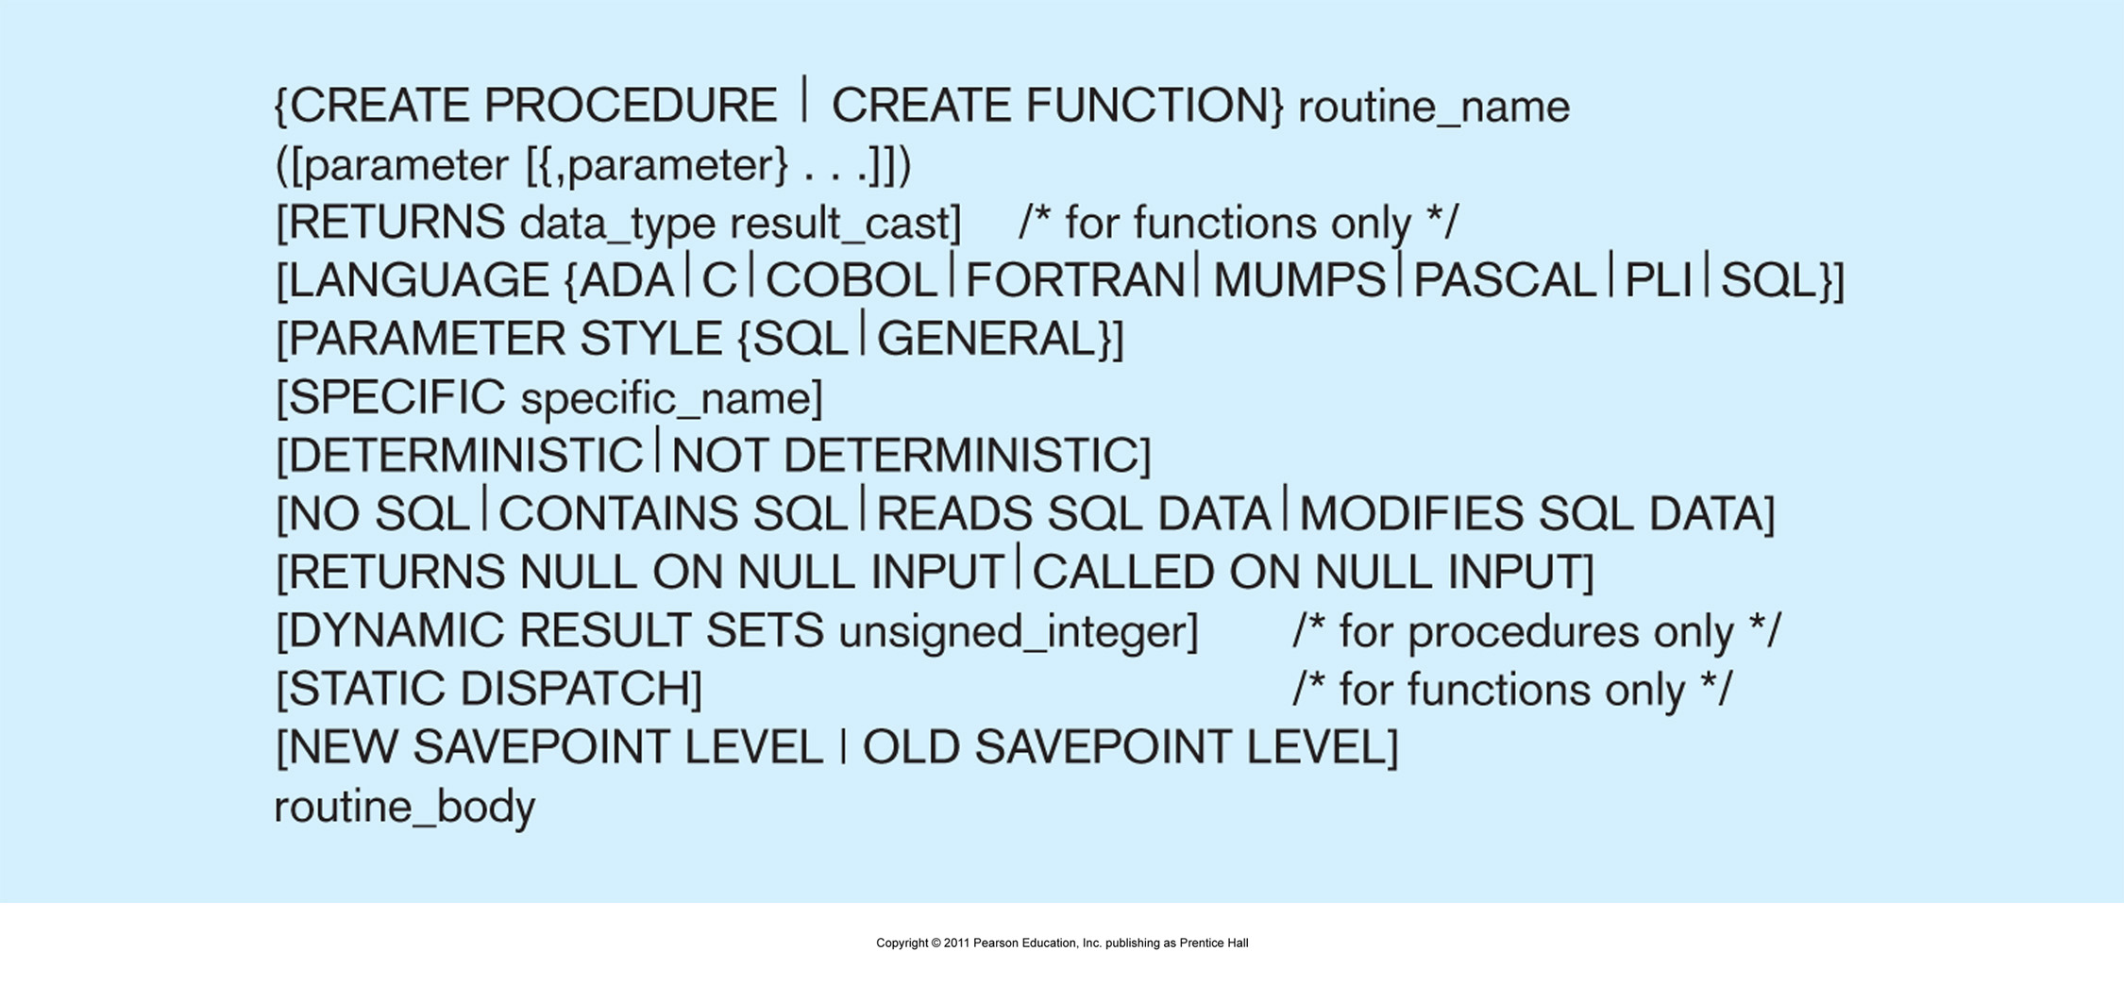

1.
a. Create a simple procedure ProductLineSale, to be used by that will set a sale price to the existing Product table in the COSC3380 Database by adding a new column, SalePrice DECIMAL (6,2), that will hold the sale price for the products:

(Original Product Table)
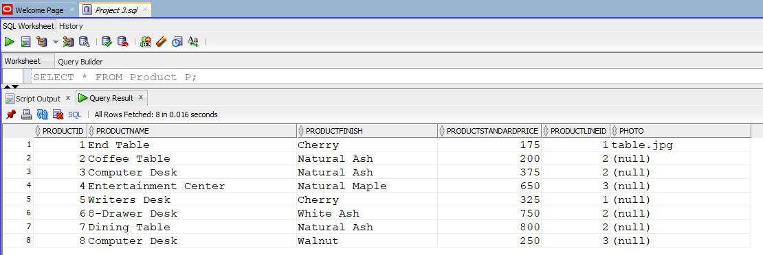

The ProductLineSale procedure should scan all rows of the Product table. Products with a ProductStandardPrice of $400 or higher are discounted 10 percent, and products with a ProductStandardPrice of less than $ 400 are discounted 15 percent. As with other database objects, there are Oracle SQL commands to create, alter, replace, drop, and show the code for procedures.

b. Run the ProductLineSale procedure in Oracle.

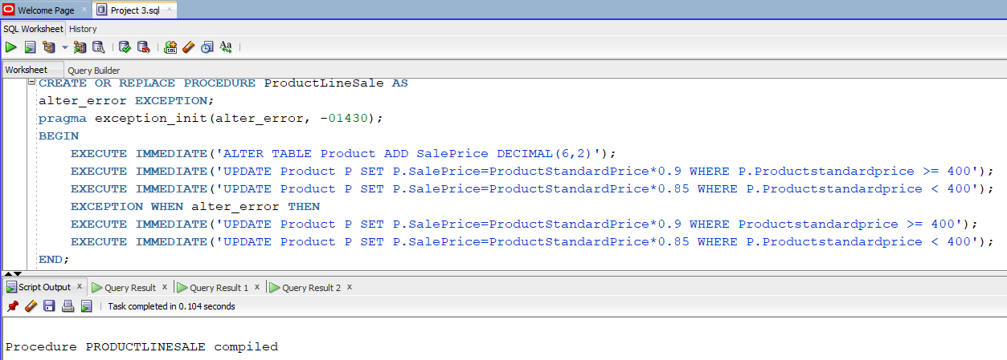
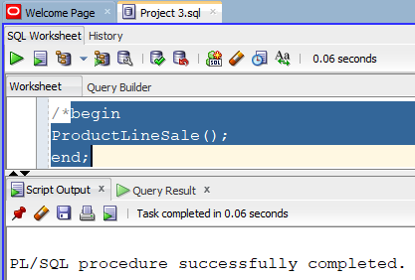

c. Display the contents of the PRODUCT table.
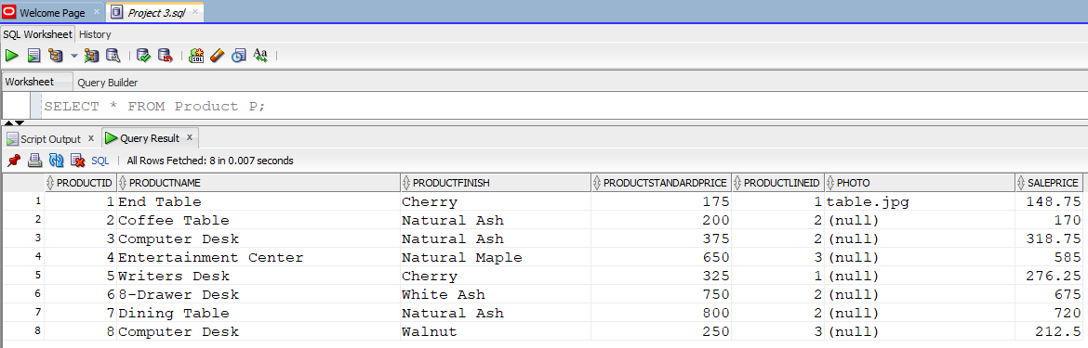
Part 2. TRIGGERS
Prior to the issuance of SQL: 1999, no support for user- defined functions or procedures was included in the SQL standards. Commercial products, recognizing the need for such capabilities, have provided them for some time, and we expect to see their syntax change over time to be in line with the SQL: 1999 requirements, just as we expect to see inclusion of SQL/ PSM standards.

Triggers and routines are very powerful database objects because they are stored in the database and controlled by the DBMS. Thus, the code required to create them is stored in only one location and is administered centrally. As with table and column constraints, this promotes stronger data integrity and consistency of use within the data-base; it can be useful in data auditing and security to create logs of information about data updates. Not only can triggers be used to prevent unauthorized changes to the database, they can also be used to evaluate changes and take actions based on the nature of the changes. Because triggers are stored only once, code maintenance is also simplified ( Mullins, 1995). Also, because they can contain complex SQL code, they are more powerful than table and column constraints; however, constraints are usually more efficient and should be used instead of the equivalent triggers, if possible. A significant advantage of a trigger over a constraint to accomplish the same control is that the processing logic of a trigger can produce a customized user message about the occurrence of a special event, whereas a constraint will produce a standardized, DBMS error message, which often is not very clear about the specific event that occurred. Both triggers and routines consist of blocks of procedural code. Routines are stored blocks of code that must be called to operate ( see figure below). They do not run automatically. In contrast, trigger code is stored in the database and runs automatically whenever the triggering event, such as an UPDATE, occurs. Triggers are a special type of stored procedure and may run in response to either DML or DDL commands. Trigger syntax and functionality vary from RDBMS to RDBMS. A trigger written to work with an Oracle database will need to be rewritten if the database is ported to Microsoft SQL Server and vice versa. For example, Oracle triggers can be written to fire once per INSERT, UPDATE, or DELETE command or to fire once per row affected by the command. Microsoft SQL Server triggers can fire only once per DML command, not once per row.
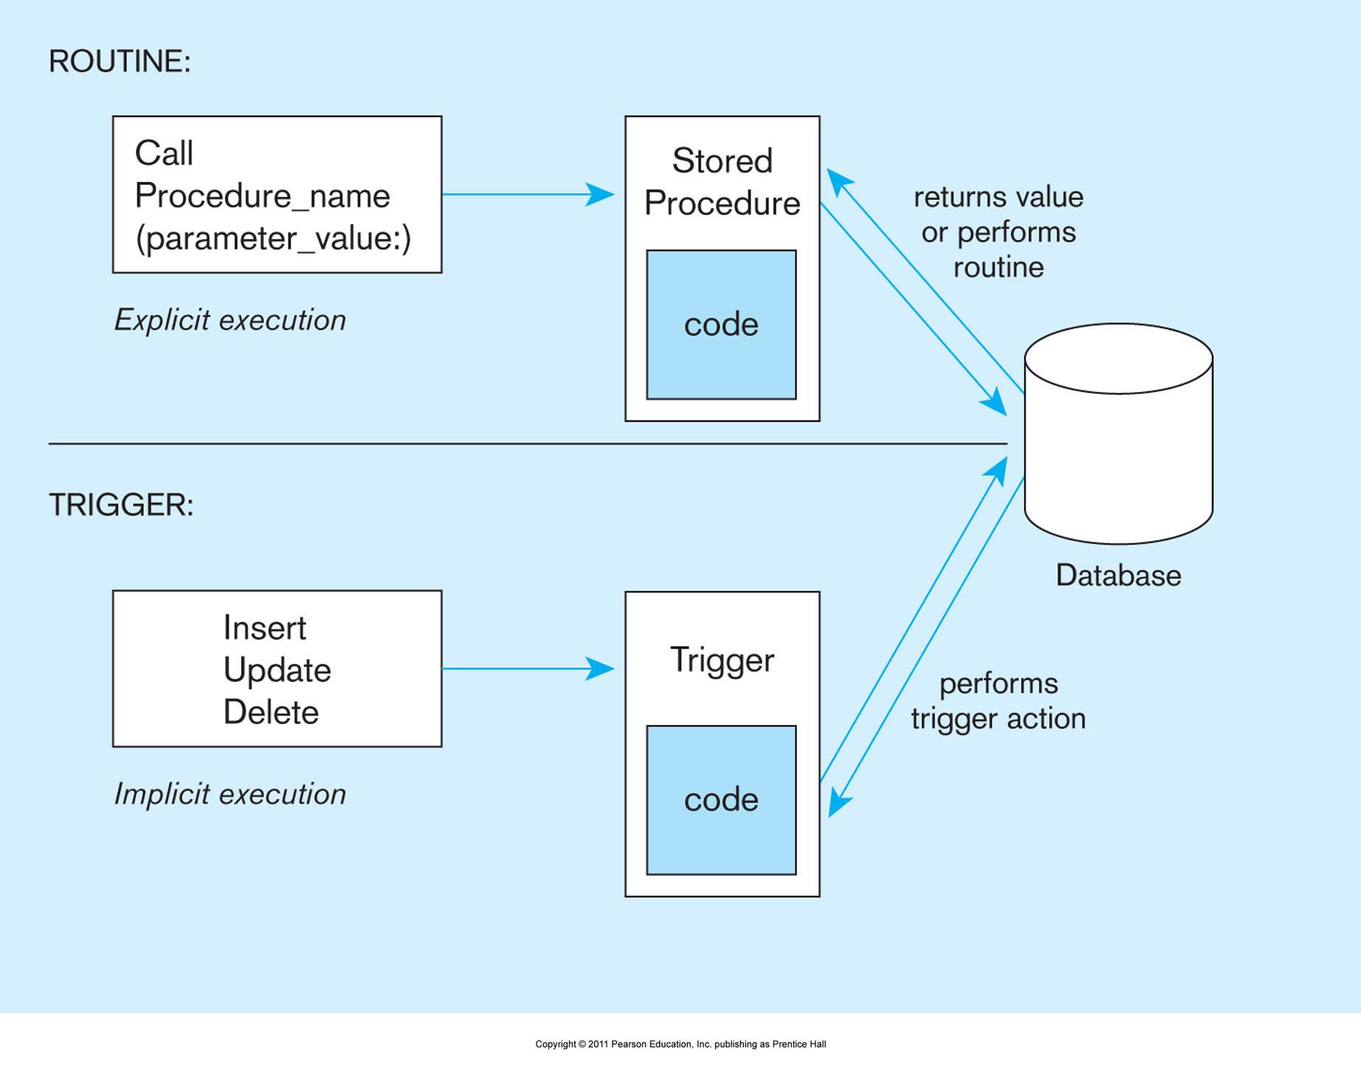
Triggers

Because triggers are stored and executed in the database, they execute against all applications that access the database. Triggers can also cascade, causing other triggers to fire. Thus, a single request from a client can result in a series of integrity or logic checks being performed on the server without causing extensive network traffic between client and server. Triggers can be used to ensure referential integrity, enforce business rules, create audit trails, replicate tables, or activate a procedure (Rennhackkamp, 1996).
Constraints can be thought of as a special case of triggers. They also are applied (triggered) automatically as a result of data modification commands, but their precise syntax is determined by the DBMS and does not have the flexibility of a trigger.
Triggers are used when you need to perform, under specified conditions, a certain action as the result of some database event ( e. g., the execution of a DML statement such as INSERT, UPDATE, or DELETE or the DDL statement ALTER TABLE). Thus, a trigger has three parts— the event, the condition, and the action— and these parts are reflected in the coding structure for triggers. (See below the simplified trigger syntax.)

Consider the following example: The inventory manager needs to know (the action of being informed) when an inventory item’s standard price is updated in the Product table (the event). After creating a new table, PriceUpdates, write a trigger that enters each product when it is updated, the date that the change was made, and the new standard price that was entered.

CREATETRIGGER trigger_ name
{ BEFORE| AFTER | INSTEAD OF}
{ INSERT | DELETE | UPDATE} ON table_ name
[ FOR EACH { ROW | STATEMENT}] [WHEN ( search condition)]
< triggered SQL statement here>;

- Write and run the trigger named StandardPriceUpdate
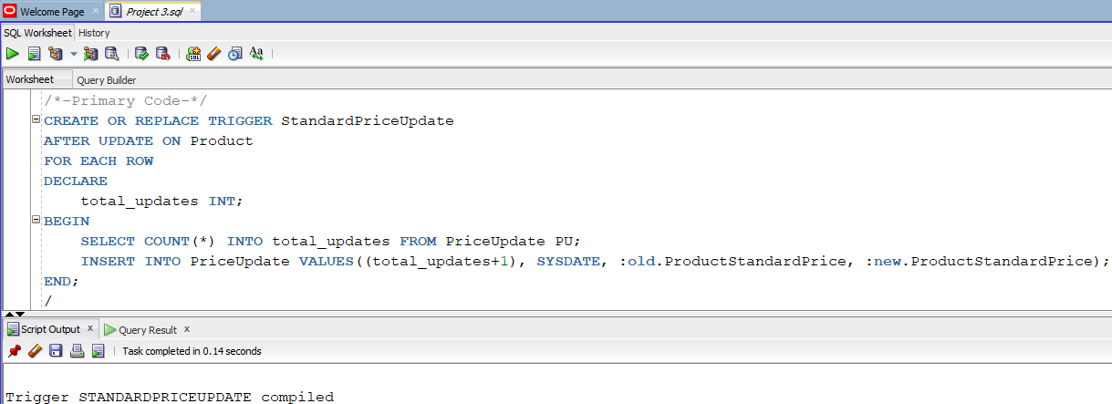

(Original Update Table)
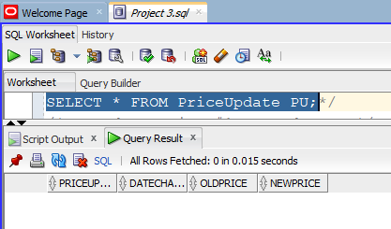

(Test Cases)
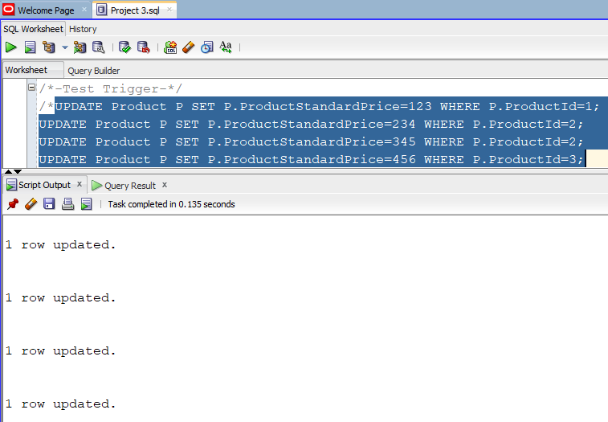
(Original Product Table)

(Result Product Table)
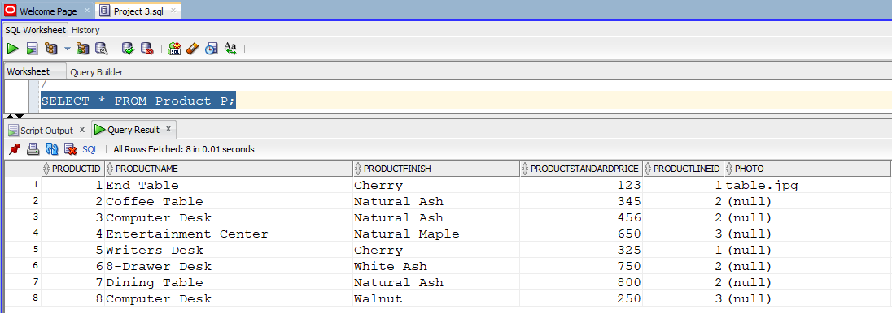

(Result Update Table)
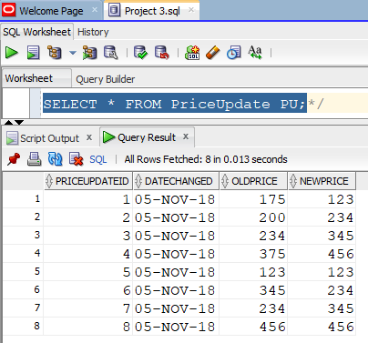

DDL triggers are useful in database administration and may be used to regulate database operations and perform auditing functions. They fire in response to DDL events such as CREATE, ALTER, DROP, GRANT, DENY, and REVOKE. The sample trigger below, taken from SQL Server 2008 Books Online [ http:// msdn2. microsoft. com/ en- us/ library/ ms175941], demonstrates how a trigger can be used to prevent the unintentional modification or drop of a table in the database:
Part 3. Accessing COSC3380 Database from JSP
(PHP (Optional)
ASP (Optional))

THREE- TIER ARCHITECTURES

In general, a three-tier architecture includes another server layer in addition to the client and database server layers previously mentioned (see Figure below). Such configurations are also referred to as n- tier, multitier, or enhanced client/ server architectures. The additional server in a three-tier architecture may be used for different purposes. Often, application programs reside and are run on the additional server, in which case it is referred to as an application server. Or the additional server may hold a local data-base while another server holds the enterprise database. Each of these configurations is likely to be referred to as a three- tier architecture, but the functionality of each differs, and each is appropriate for a different situation. Advantages of the three- tier compared with the two- tier architecture, such as increased scalability, flexibility, performance, and reusability, have made three-layer architectures a popular choice for Internet applications and net-centric information systems.

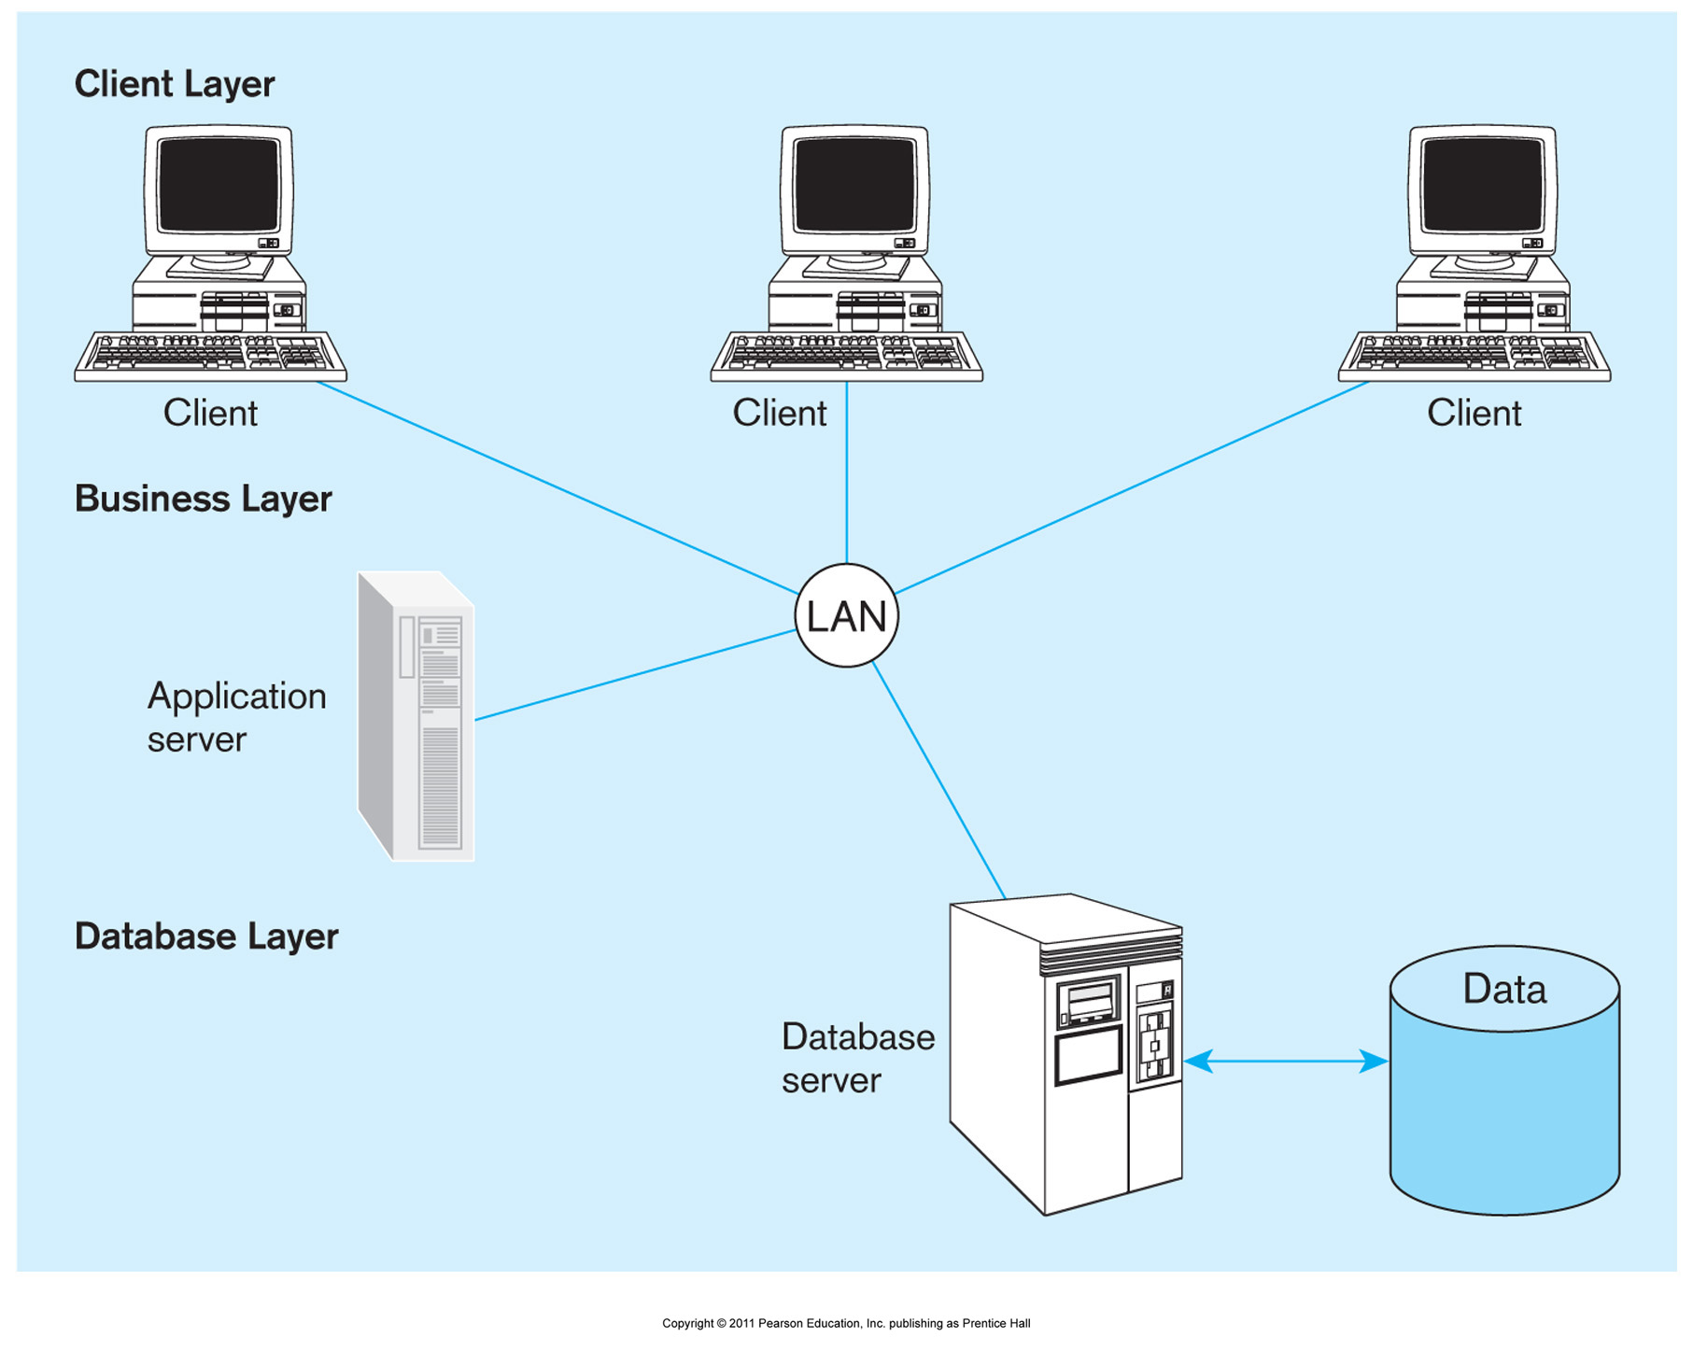

The most common type of three-tier application in use in modern organizations is a Web-based application. Such applications can be accessed from either the Internet or an intranet. Figure below depicts the basic environment needed to set up both intranet and Internet database-enabled connectivity. In the box on the right side of the diagram is a depiction of an intranet. The client/ server nature of the architecture is evident from the labeling. The network that connects the client workstations, Web server, and database server uses TCP/ IP. While multitier intranet structures are also used, the figure depicts a simpler architecture, where a request from a client browser will be sent through the network to the Web server, which stores pages scripted in HTML to be returned and displayed through the client browser. If the request requires that data be obtained from the database, the Web server constructs a query and sends it to the database server, which processes the query and returns the results set when the query is run against the database. Similarly, data entered at the client station can be passed through and stored in the database by sending it to the Web server, which passes it on to the database server, which commits the data to the database. The processing flow described here is similar when connecting from outside the company. This is the case whether the connection is available only to a particular customer or supplier or to any workstation connected to the Internet. However, opening up the Web server to the outside world requires that additional data security measures be in place.
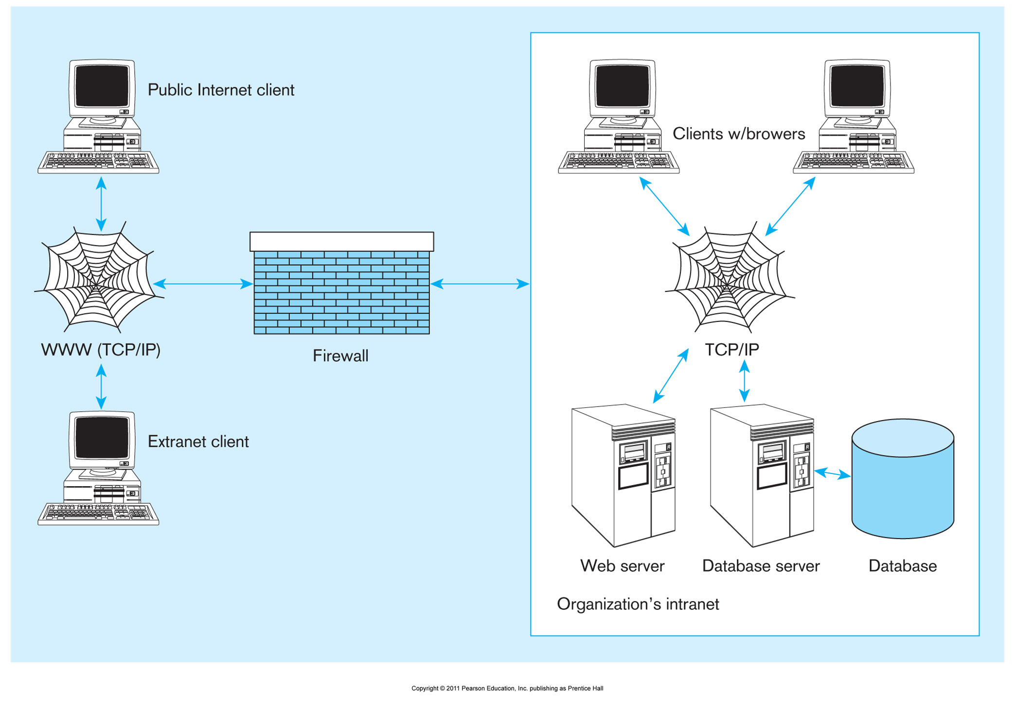

Internally, access to data is typically controlled by the database management system, with the database administrator setting the permissions that determine employee access to data. Firewalls limit external access to the company’s data and the movement of company data outside the company’s boundaries. All communication is routed through a proxy server outside of the organization’s network. The proxy server controls the passage of messages or files through to the organization’s network. It can also improve a site’s performance by caching frequently requested pages that can then be displayed without having to attach to the Web server. The most common type of three-tier application is a Web application, you will design and implement simple Web applications written in three common languages: Java Server Pages (JSP), PHP, and ASP.

WEB APPLICATION COMPONENTS

Figure below shows the various components of a typical Web application.
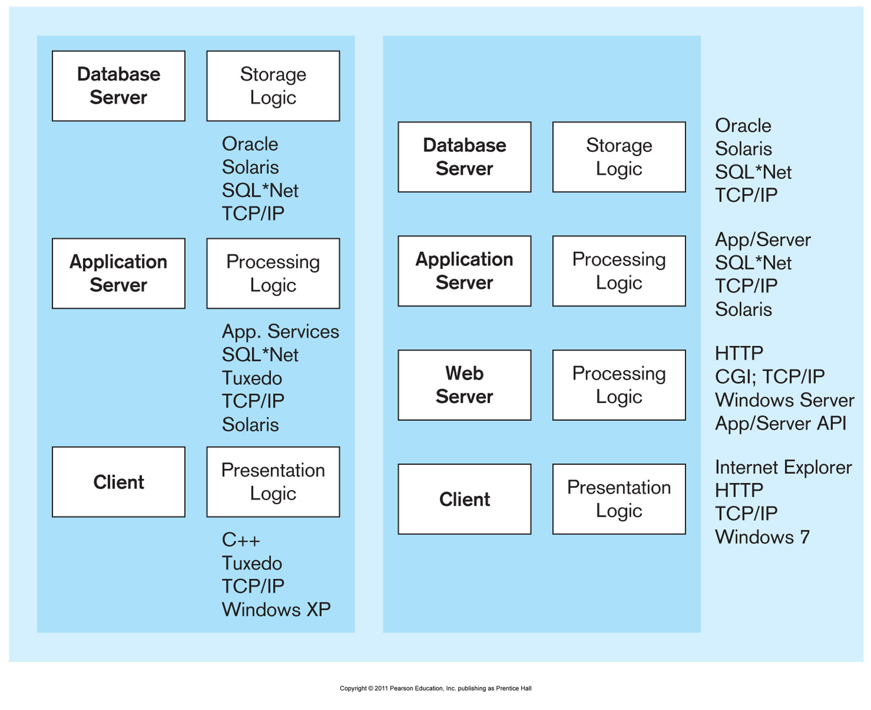

Four key components must be used together to create a Web application site:

1. A database server This server hosts the storage logic for the application and hosts the DBMS. You have read about many of them, including Oracle, Microsoft SQL Server, Informix, Sybase, DB2, Microsoft Access, and MySQL. The DBMS may reside either on a separate machine or on the same machine as the Web server.

2. A Web server The Web server provides the basic functionality needed to receive and respond to requests from browser clients. These requests use HTTP or HTTPS as a protocol. The most common Web server software in use is Apache, but you are also likely to encounter Microsoft’s Internet Information Server (IIS) Web server. Apache can run on different operating systems, such as Windows, UNIX, or Linux. IIS is primarily intended to run on Windows servers.

3. An application server This software provides the building blocks for creating dynamic Web sites and Web-based applications. Examples include the . NET Framework from Microsoft; Java Platform, Enterprise Edition (Java EE); and ColdFusion. Also, while technically not considered an application server plat-form, software that enables you to write applications in languages such as PHP, Python, and Perl also belong to this category.

4. A Web browser Microsoft’s Internet Explorer, Mozilla’s Firefox, Apple’s Safari, Google’s Chrome, and Opera are examples.

As you can see, a bewildering collection of tools are available to use for Web application development. Although Figure above gives an overview of the architecture required, there is no one right way to put together the components. Rather, there are many possible configurations, using redundant tools. Often, Web technologies within the same category can be used interchangeably. One tool may solve the same problem as well as another tool. However, the following are the most common combinations you will encounter:

• IIS Web server, SQL Server/ Oracle as the DBMS, and applications written in ASP. NET

• Apache Web server, Oracle/ IBM as the DBMS, and applications written using Java

• Apache Web server, Oracle/ IBM/ SQL Server as the DBMS, and applications writ-ten using ColdFusion

• The Linux operating system, Apache Web server, a MySQL database, and applications written in PHP/ Python or Perl (also sometimes referred to as the LAMP stack).

Your development environment is likely to be determined by your client. When you know what environment you will be using, there are many alternatives available for becoming familiar and proficient with the tools. Figure below presents a visual depiction of the components necessary to create a dynamic Web site.

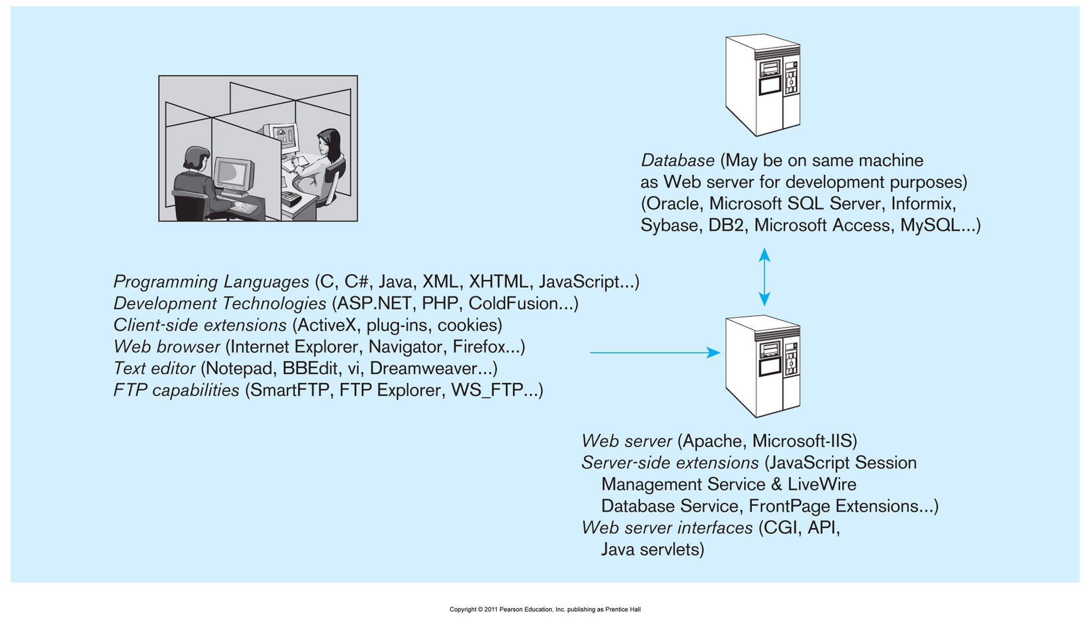

Languages for Creating Web Pages

The World Wide Web Consortium (W3C) is the chief standards body for HTTP and HTML. Founded in 1994 by Tim Berners-Lee, W3C is an international consortium of companies. W3C’s intent is to develop open standards that foster the development of Web conventions so that Web documents can be consistently displayed across all platforms. The consortium organizes its work into four domains, each of which reports its current activities on the W3C Web site (www. w3. org). The four domains are Architecture, Interaction, Technology and Society, and the Web Accessibility Initiative. The fundamental authoring language used to create documents for the Web is Hypertext Markup Language (HTML). HTML is similar to Standard Generalized Markup Language (SGML), which states the rules for tagging elements of a document so that they can be formatted in a standard way. HTML tag conventions are based on SGML rules. HTML is a scripting language intended to define Web document structure and layout for display purposes, using a variety of tags and attributes. For example, an HTML document starts with the tags (document subject is entered here). The information to be displayed and additional formatting tags follow, and the document will end with the tags. XML is a rapidly developing scripting language, also based on SGML, that has been widely accepted as a means of capturing data structure. XML is an acronym for Extensible Markup Language, a specification developed by the W3C. Designed especially for Web documents, XML allows the creation of customized tags. These tags can be used across organizations, enabling the definition, transmission, validation, and interpretation of data between applications and between organizations. XML has also proved useful for attaching legacy data to the Web because the XML tags can be used to define data as it is formatted in the legacy data store, thus eliminating the need to reformat it. We discuss XML in detail later in this chapter. W3C has issued specifications for a hybrid scripting language, Extensible Hypertext Markup Language (XHTML), which extends HTML code to make it XML compliant. XHTML uses three XML namespaces that correspond to three HTML 4.0 data type definitions (DTDs): Strict, Transitional, and Frameset. Because the modules used in XHTML conform to certain standards, layout and presentation remain consistent across platforms. The W3C wants XHTML to replace HTML as the standard scripting language. It is recommended that the reader visit the W3C Web site to learn how close the organization is to accomplishing this objective. The languages mentioned thus far are scripting or markup languages, intended for handling layout and display of documents (or, in the case of XML, handling data definition and interpretation) rather than for programming functions or activities. Web pages also contain code written in JavaScript (not be confused with Java). Web authors use JavaScript to achieve interactivity and introduce dynamic content. For example, mouse rollovers, automatic notices that content has been updated, and error handling can be accomplished through JavaScript embedded in the HTML code. When an event occurs, such as the mouse rolling over a button, the JavaScript will be activated. JavaScript is an open language and does not require a license. It is supported by Internet Explorer and other browsers. VBScript is similar to JavaScript. Just as JavaScript is based on Java but is simpler, VBScript is based on Visual Basic and is also simpler. VBScript can be used to add buttons, scrollbars, and other interactive controls to a Web page. Microsoft developed this scripting language, and it is supported by the Microsoft Internet Explorer browser. Now that we have seen the technologies that can be used to create HTML pages, let us turn our attention toward understanding how a Web server, an application server, and a database server can be combined create a database- driven Web application. We will look at examples of such applications in three popular languages: JSP, ASP. NET, and PHP.

DATABASES IN THREE-TIER APPLICATIONS

Figure below presents a general overview of the information flow in a Web application. A user submitting a Web page request is unaware of whether the request being submitted is returning a static Web page or a Web page whose content is a mixture of static information and dynamic information retrieved from the database. The data returned from the Web server is always in a format that can be rendered by the browser ( i. e., HTML or XML). As shown in Figure below, if the Web server determines that the request from the client can be satisfied without passing the request on to the application server, it will process the request and then return the appropriately formatted information to the client machine. This decision is most often based on the file suffix. For example, all . html and . htm files can be processed by the Web server itself.

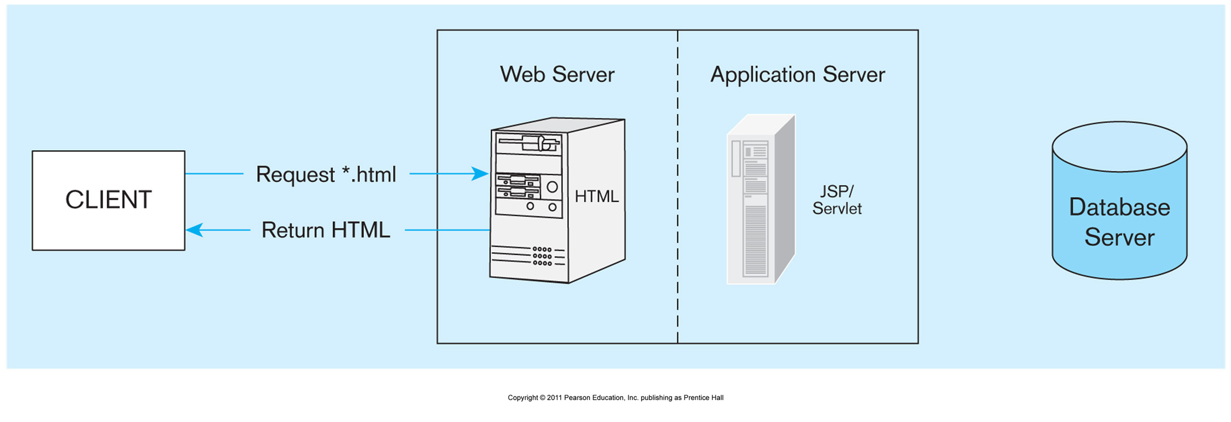

However, if the request has a suffix that requires application server intervention, the information flow show in Figure below is invoked. The application invokes the data-base, as necessary, using one of the mechanisms described previously (ADO. NET or JDBC) or a proprietary one. While the internal details of how each of the popular plat-forms (JSP/ Java servlets, ASP. NET, ColdFusion, and PHP) handle the requests are likely very different, the general logic for creating Web applications is very similar to what is shown in Figure below.

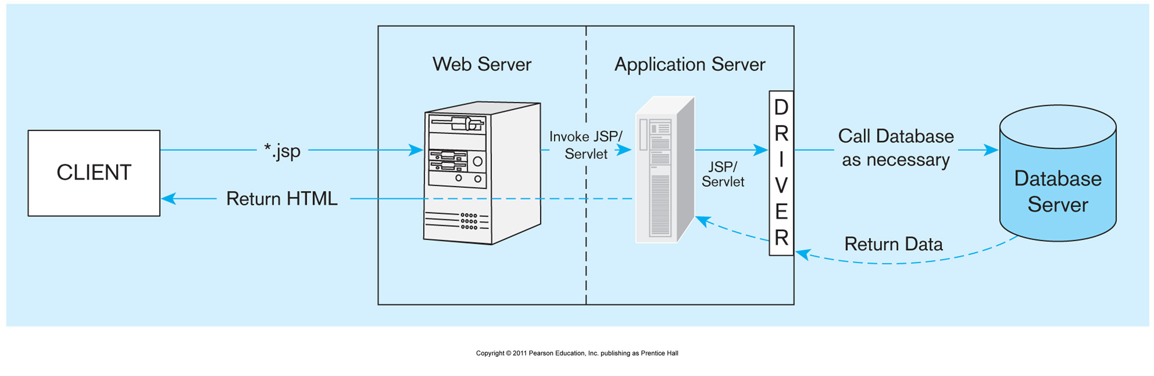
Create a simple Web Page whose purpose is to display SalestoDate from the database, a report that will be used by the Product Manager (product ID, product description, #number of times the product was ordered.

A JSP Web Page
Create SalestoDate.jsp

(jsp page oracle 12c DBMS backend)

(Optional) A PHP Web Page
Java, C, C++, C#, and Perl are APIs that can be used with MySQL. PHP is one of the most popular APIs for several reasons. Support for MySQL has been built into PHP since PHP4. It has a reputation for ease of use, short development time, and high performance. PHP5, recently released, is more object oriented than PHP4 and includes several class libraries. It is considered to be relatively easy to learn. Intermediate- level programmers will learn it quickly.
Create SalestoDate.php

(php page mysql DBMS backend; Please create and turn in Project3mysql.sql)

(Optional) An ASP.NET Web Page
Create SalestoDate.aspx

(asp page oracle 12c DBMS backend)

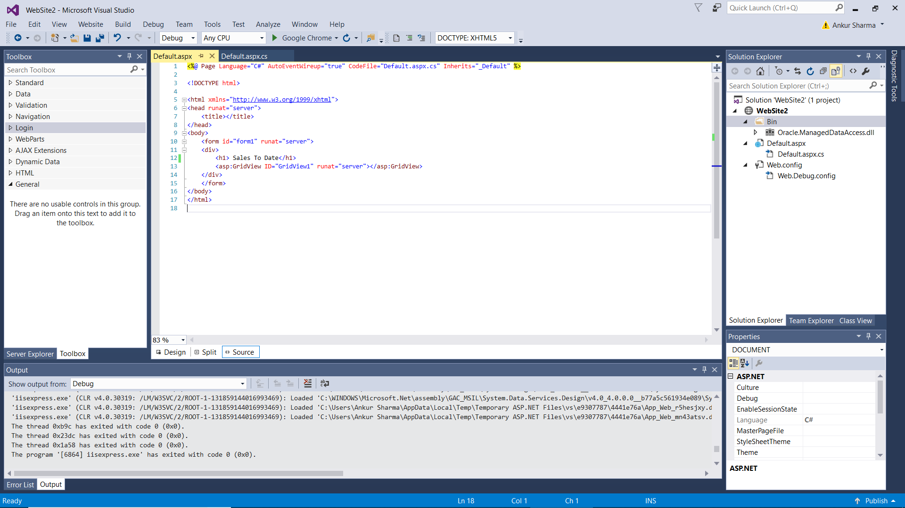

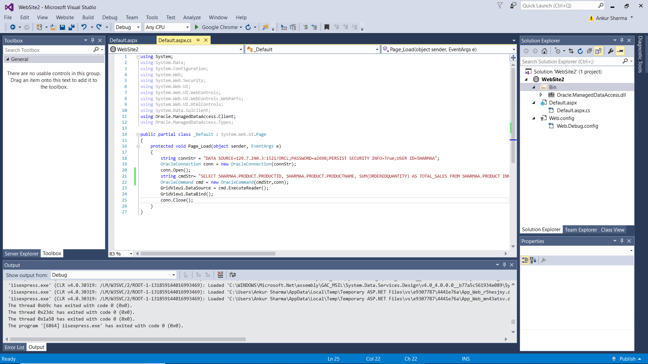

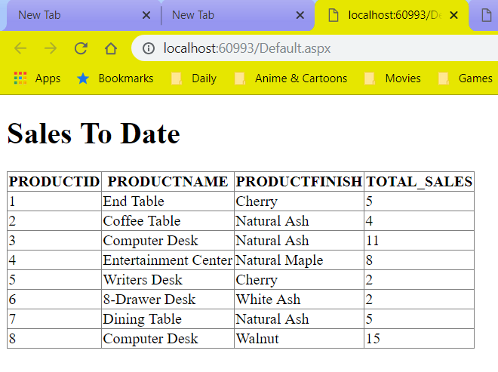

You need to turn in hard copy and electronic:
. The .sql scripts with comments, Project3.sql. (only to BB)
. The .zip of the 3 Projects (2 NetBeans; 1 Visual Studio). (only to BB)

. The screenshots of Stored Procedures, Trigger, NetBeans 6.9.1 & Visual Studio 2010 Projects, Web Pages AND the source CODE, Project3.doc. (BOTH to BB and HARDCOPY)

Without Project3.doc you will get ZERO!

You are to download your ZIPPED ASP.NET Project / NetBeans Project/ PHP Project into BB then to your local computer in 232 PGH in the first 10 minutes of the class.
PLEASE DO NOT RAR!

